Advantzware Open Analytics (AOA)

Query Creation User Manual

When attempting to use an AOA Report in the Auto Scheduler, if the output format desired is Excel, there is an issue in how it renders if columns are deselected and/or the column order is changed. The process first creates the report in AOA format, then attempts to place the data into the Excel columns based on the pixel position. This is quite complicated and prone to the Excel process not rendering as anticipated.

If exporting to Excel via the Auto Scheduler is required, this guide will explain how to extract the AOA query from the report and using the Excel DataPA Add-In, show how to use the Query Wizard for modifying the Query to create the desired Excel results.

Double click the AOA Report from Windows Explorer (or open Report Designer and open the AOA Report.

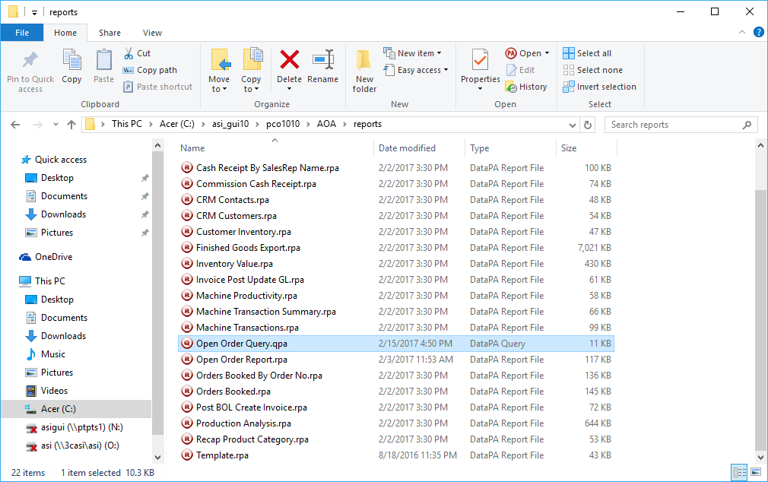

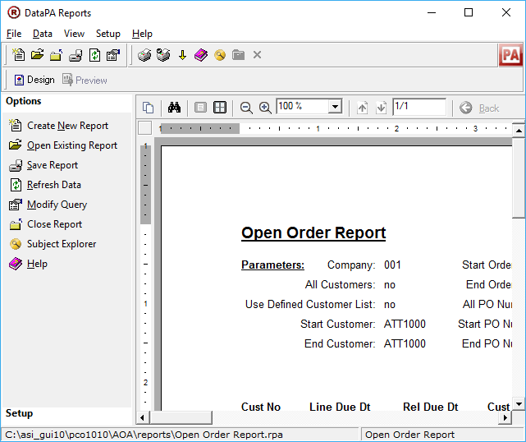

Select “Setup” menu option and click “Share Query”.

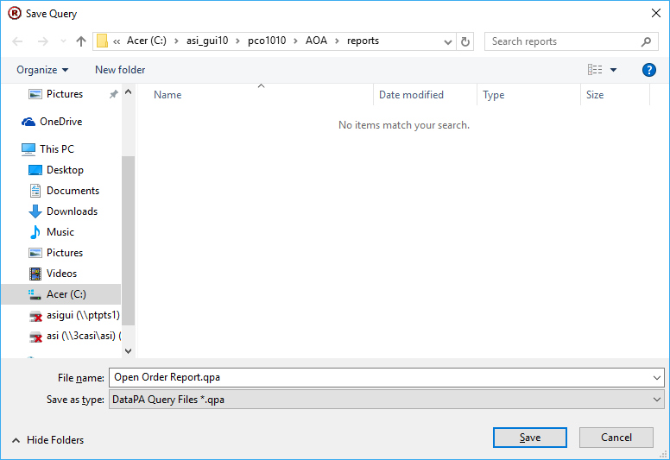

Save the default name given which is the Report name with a “.qpa” extension.

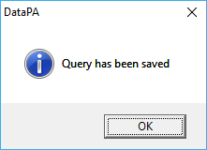

Close the Report Designer.

Open Excel and locate the Add-Ins tab.

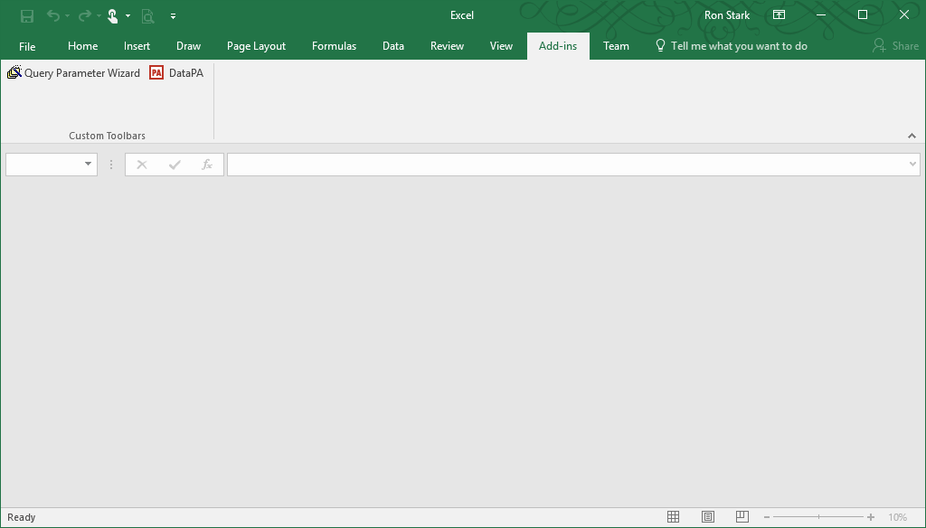

Click the “DataPA” Add-In which will run the Query Wizard.

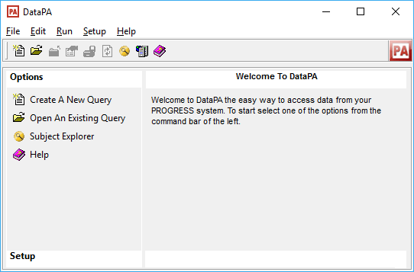

Open An Existing Query.

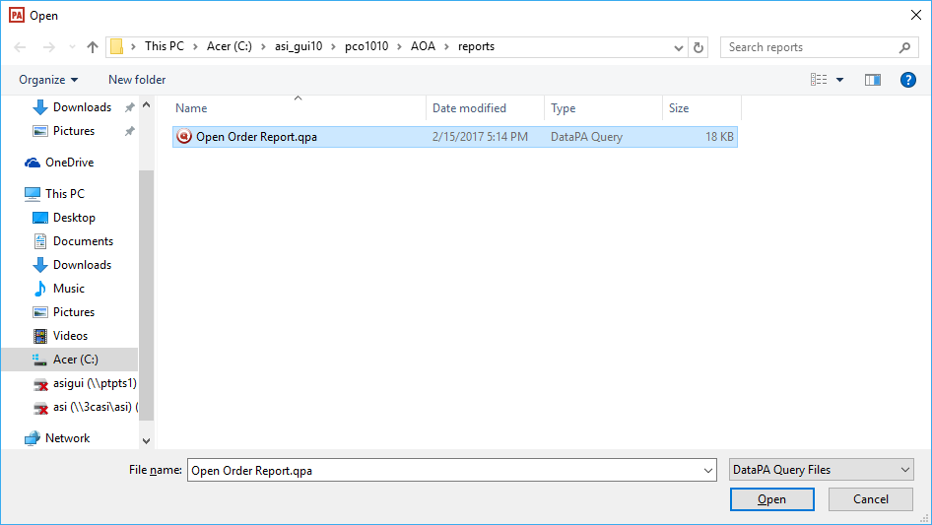

Now click to Modify Query.

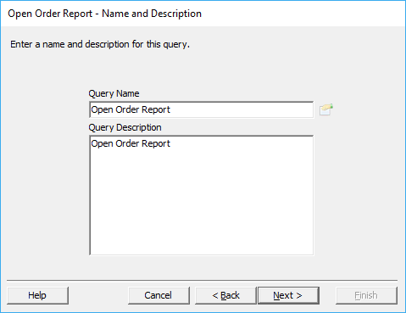

Click Next.

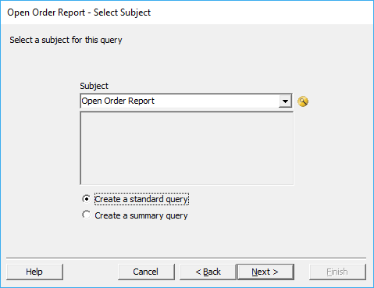

Click Next.

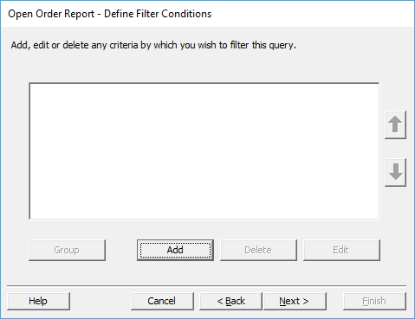

Click Add.

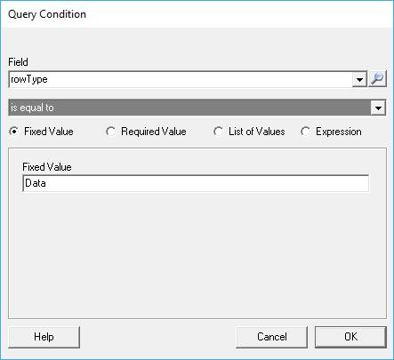

Here select field “rowType” and in “Fixed Value”, enter “Data”. This done because at the top of the dataset returned by AOA is a record with MetaData used to parse and structure the resulting AOA Reports. If this “rowType” query condition is not set, this record will appear in the Excel sheet as the first record.

Click OK and Next.

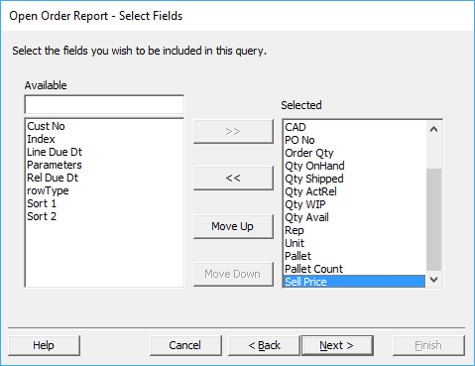

And remove from the right column any fields that are not desired to appear in the Excel sheet. Note any fields labeled Sort, rowType, Parameters and/or Index, should probably be unselected. Also, any changes in which the order of columns should be changed, is done here using the “Move Up” and “Move Down” buttons.

Click Next.

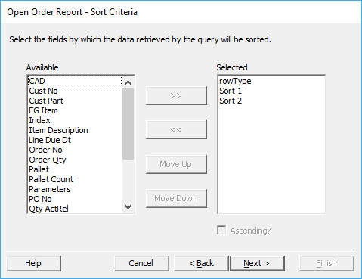

If the sort order needs adjusting, this is the wizard screen to make those changes. Normally, this should remain as configured.

Click Next.

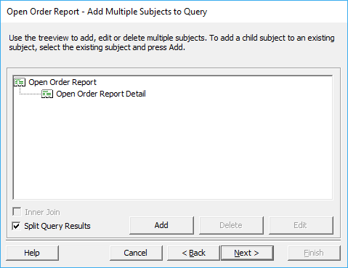

It is recommended these values remain as configured and simply click Next.

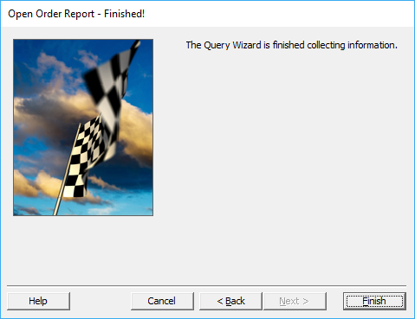

Now click Finish.

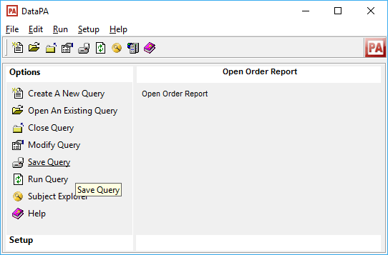

Select “Save Query”.

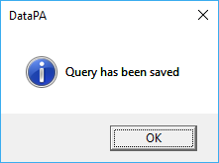

Open the Scheduler and if a Task does not already exist, create one.

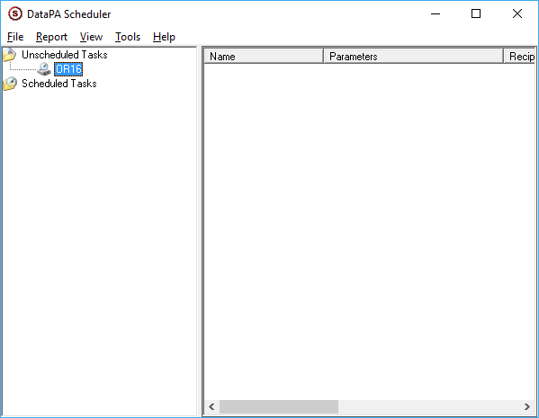

Under Report, Add Report.

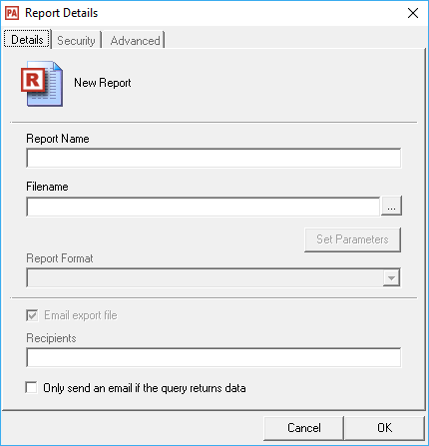

Click the button labeled “ … “ to the right of Filename.

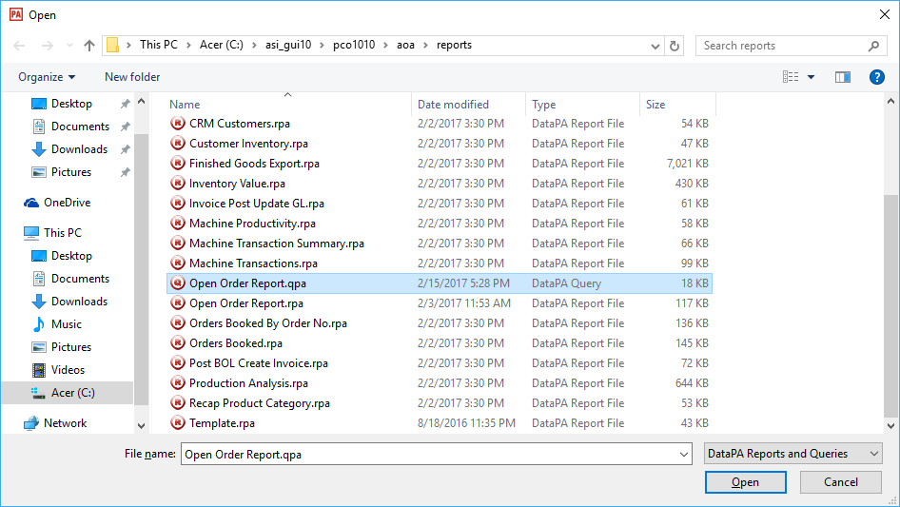

Select the desired Query (.qpa extension).

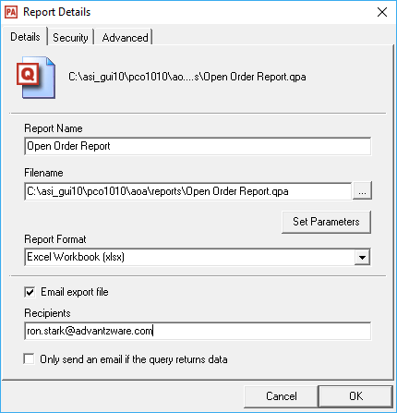

It will auto select the Excel Workbook (xlsx) format. Populate the Recipients and click OK.

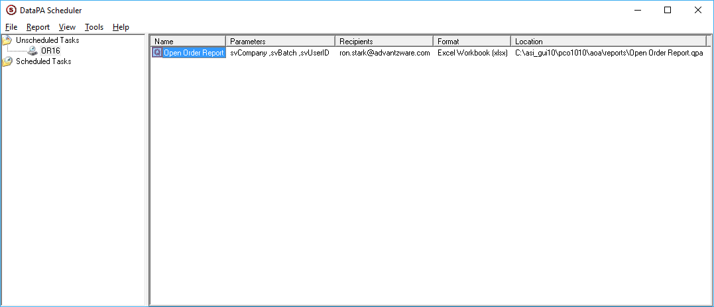

Right mouse click the Report and select “Change Parameters”. Use the same Parameter values for company, batch and user that would normally be used when running the AOA Report this Query was created from.

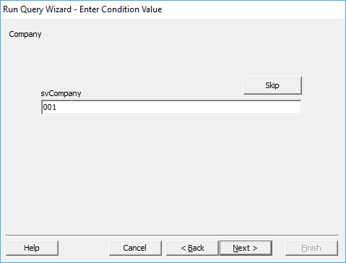

Enter the Company value that a Batch was created under. Click Next.

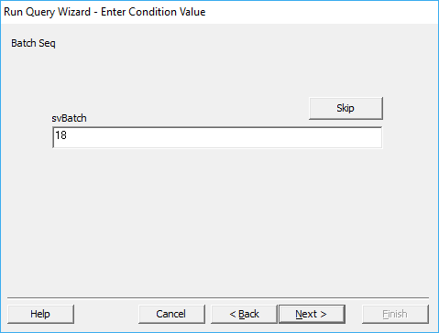

Enter the Batch value. Click Next.

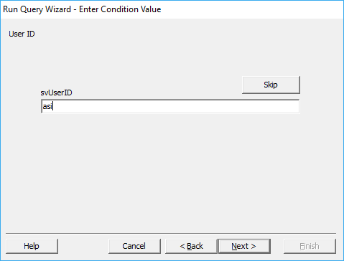

Enter the user id of the batch owner. Click Next.

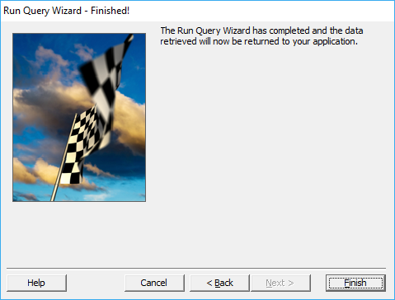

Click Finish.

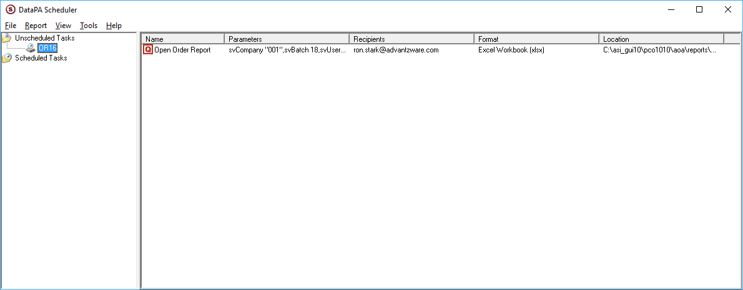

At this point the Task can be scheduled or right mouse click the Task and perform a Run Now to test both the output is as desired and/or the Email Recipients receive the Excel Sheet.

You can review the log file by selecting “Tools” and then “View log file”. Normal operation should return the following:

2/15/2017 5:50:48 PM 7768 0 I DataPA_Sched *****************************************************************************************

2/15/2017 5:50:48 PM 7768 0 I DataPA_Sched PROCESSING STARTED

2/15/2017 5:50:48 PM 7768 0 I DataPA_Sched Logfile: C:\ProgramData\DataPA\Scheduler.log

2/15/2017 5:50:48 PM 7768 0 I DataPA_Sched Logfile Sender 's Address: ron.stark@advantzware.com

2/15/2017 5:50:48 PM 7768 0 I DataPA_Sched Logfile Recipient's Address:

2/15/2017 5:50:48 PM 7768 0 I DataPA_Sched ----------------------------------------------------------------------------------------

2/15/2017 5:50:48 PM 7768 0 I DataPA_Sched Job Configfile Found: C:\ProgramData\DataPA\OR16.jpa - Starting Reports...

2/15/2017 5:50:48 PM 7768 0 I DataPA_Sched ----------------------------------------------------------------------------------------

2/15/2017 5:50:48 PM 7768 0 I DataPA_Sched Creating DataPA Objects...

2/15/2017 5:50:56 PM 7768 0 I DataPA_Sched ----------------------------------------------------------------------------------------

2/15/2017 5:50:56 PM 7768 0 I DataPA_Sched Repeat Interval is 0 minutes

2/15/2017 5:50:56 PM 7768 0 I DataPA_Sched Repeat Duration is 0 minutes

2/15/2017 5:50:56 PM 7768 0 I DataPA_Sched Starting Job: Open Order Report

2/15/2017 5:50:56 PM 7768 0 I DataPA_Sched Language File Path from Job: C:\Program Files (x86)\DataPA\Bin\..\Common\

2/15/2017 5:50:56 PM 7768 0 I DataPA_Sched Language File Path Used: C:\Program Files (x86)\DataPA\Bin\..\Common\

2/15/2017 5:50:56 PM 7768 0 I DataPA_Sched Recipient: ron.stark@advantzware.com

2/15/2017 5:50:56 PM 7768 0 I DataPA_Sched Temp File Name: C:\ProgramData\DataPA\data\Open Order Report.xlsx

2/15/2017 5:50:56 PM 7768 0 I DataPA_Sched Parameter Values: "001"18"nosweat"

2/15/2017 5:50:56 PM 7768 0 I DataPA_Sched Using default connection AdvantzwareOA for system AdvantzwareOA

2/15/2017 5:50:56 PM 7768 0 I DataPA_Sched Apply Query Settings - Selected Connection AdvantzwareOA

2/15/2017 5:50:59 PM 7768 0 I DataPA_Sched Start write excel file Open Order Report.xlsx

2/15/2017 5:51:01 PM 7768 0 I DataPA_Sched Excel file Open Order Report.xlsx created ok

2/15/2017 5:51:01 PM 7768 0 I DataPA_Sched Workbook created ok

2/15/2017 5:51:02 PM 7768 0 I DataPA_Sched Data added OK

2/15/2017 5:51:02 PM 7768 0 I DataPA_Sched Labels added OK

2/15/2017 5:51:02 PM 7768 0 I DataPA_Sched Labels added OK

2/15/2017 5:51:02 PM 7768 0 I DataPA_Sched Labels added OK

2/15/2017 5:51:02 PM 7768 0 I DataPA_Sched Labels added OK

2/15/2017 5:51:02 PM 7768 0 I DataPA_Sched Labels added OK

2/15/2017 5:51:02 PM 7768 0 I DataPA_Sched Labels added OK

2/15/2017 5:51:02 PM 7768 0 I DataPA_Sched Labels added OK

2/15/2017 5:51:02 PM 7768 0 I DataPA_Sched Labels added OK

2/15/2017 5:51:02 PM 7768 0 I DataPA_Sched Labels added OK

2/15/2017 5:51:02 PM 7768 0 I DataPA_Sched Labels added OK

2/15/2017 5:51:02 PM 7768 0 I DataPA_Sched Labels added OK

2/15/2017 5:51:02 PM 7768 0 I DataPA_Sched Labels added OK

2/15/2017 5:51:02 PM 7768 0 I DataPA_Sched Labels added OK

2/15/2017 5:51:02 PM 7768 0 I DataPA_Sched Labels added OK

2/15/2017 5:51:02 PM 7768 0 I DataPA_Sched Labels added OK

2/15/2017 5:51:02 PM 7768 0 I DataPA_Sched Labels added OK

2/15/2017 5:51:02 PM 7768 0 I DataPA_Sched Labels added OK

2/15/2017 5:51:02 PM 7768 0 I DataPA_Sched Labels added OK

2/15/2017 5:51:02 PM 7768 0 I DataPA_Sched Labels added OK

2/15/2017 5:51:02 PM 7768 0 I DataPA_Sched Labels added OK

2/15/2017 5:51:02 PM 7768 0 I DataPA_Sched Labels added OK

2/15/2017 5:51:02 PM 7768 0 I DataPA_Sched Labels added OK

2/15/2017 5:51:02 PM 7768 0 I DataPA_Sched Labels added OK

2/15/2017 5:51:02 PM 7768 0 I DataPA_Sched Labels added OK

2/15/2017 5:51:02 PM 7768 0 I DataPA_Sched Labels added OK

2/15/2017 5:51:02 PM 7768 0 I DataPA_Sched Data added ok

2/15/2017 5:51:02 PM 7768 0 I DataPA_Sched Set to bold ok

2/15/2017 5:51:02 PM 7768 0 I DataPA_Sched Autofit ok

2/15/2017 5:51:02 PM 7768 0 I DataPA_Sched Visible set ok

2/15/2017 5:51:02 PM 7768 0 I DataPA_Sched Select ok

2/15/2017 5:51:02 PM 7768 0 I DataPA_Sched Name set ok

2/15/2017 5:51:02 PM 7768 0 I DataPA_Sched Clearing Default Sheets. Checking Open Order Report is like Sheet?

2/15/2017 5:51:02 PM 7768 0 I DataPA_Sched Clearing Default Sheets. Checking Sheet1 is like Sheet?

2/15/2017 5:51:02 PM 7768 0 I DataPA_Sched Clearing Default Sheets. Checking Sheet1 is blank. Cells non zero = 0

2/15/2017 5:51:02 PM 7768 0 I DataPA_Sched Deleting Default Sheet Sheet1

2/15/2017 5:51:02 PM 7768 0 I DataPA_Sched Workbook saved ok

2/15/2017 5:51:02 PM 7768 0 I DataPA_Sched Export to Excel file Open Order Report.xlsx OK

2/15/2017 5:51:02 PM 7768 0 I DataPA_Sched Set to nothing ok

2/15/2017 5:51:02 PM 7768 0 I DataPA_Sched Query ran and exported ok

2/15/2017 5:51:07 PM 7768 0 I DataPA_Sched Mail sent.

2/15/2017 5:51:07 PM 7768 0 I DataPA_Sched Deleting export file C:\ProgramData\DataPA\data\Open Order Report.xlsx

2/15/2017 5:51:07 PM 7768 0 I DataPA_Sched ----------------------------------------------------------------------------------------

2/15/2017 5:51:07 PM 7768 0 I DataPA_Sched Destroying DataPA Objects...

2/15/2017 5:51:07 PM 7768 0 I DataPA_Sched PROCESSING COMPLETE

2/15/2017 5:51:07 PM 7768 0 I DataPA_Sched *****************************************************************************************

The Excel should render as desired.

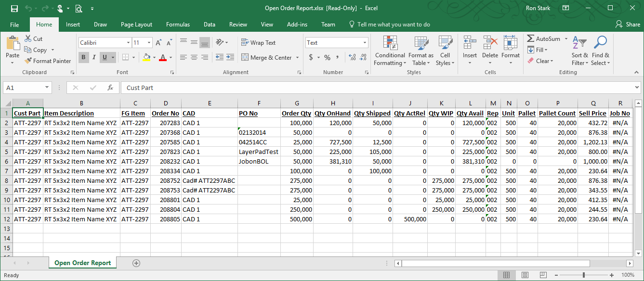

**Note:** the selections done for showing various sections of an AOA Report and/or column selections/order changes in the AOA Parameter screen are ignored. The Query only uses the Parameter values located on the left side of the screen for selecting ranges, etc.